(HERITAGE WESTERN CAPE SITE INSPECTION REPORT

Erf and Address: Buffeljags Abalone Farm 357, Bredasdorp

File Number/s: HM/ BREDASDORP/ BUFFELJAGS ABALONE FARM 357

Registered owner: Viking Aquaculture (Pty) Ltd

Zoning (if known): Farming
Suggested Grading: IIIC (from Site Inspection)
Date of site visit: 28 March 2019

HWC Representative/s: Dr Lita Webly (Committee Member)
Ms Ceciline Muller (Committee Member)
Ms Stephanie Barnadt (HWC Official)
Mr Lwazi Bhengu (HWC Official)

Reason for Site Inspection:

Follow up on a stop works order issued by HWC on discovery of archaeological materials during construction.
An HIA had been requested by HWC during the need process.
Work had commenced before the HIA was approved by HWC.

Findings and Discussion:
The first view we had of the turbines from the road was about 6 km from Buffelsjag abalone farm. We did not see it from Pearly Beach (which is 15 km away).

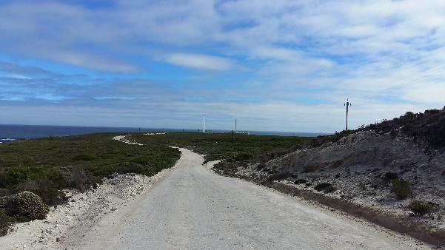
Site 003: View from the turnoff to site

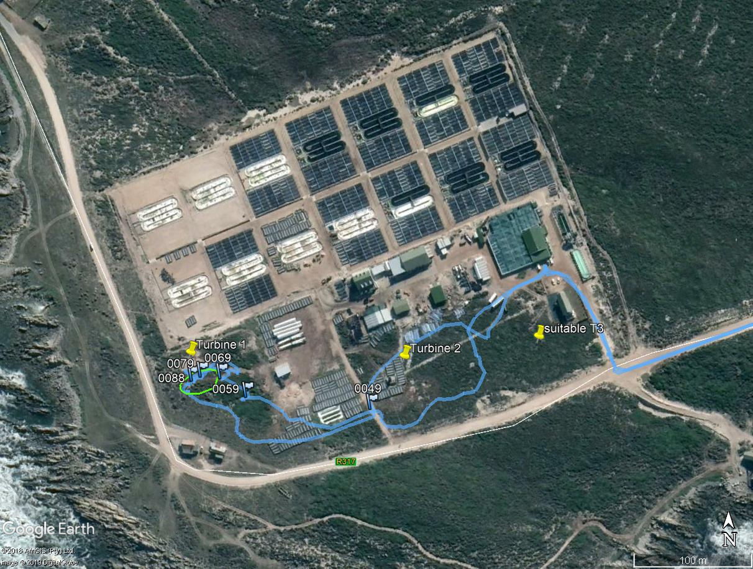
Aerial View of the Buffeljags Abalone Farm

The Turbine positions are shown below as yellow pins.
The area around “suitable T3” pin, is underlain by very shallow calcrete, and there appears to be no shell in this area (with the exception of recent abalone shell which is derived from the abalone farm).

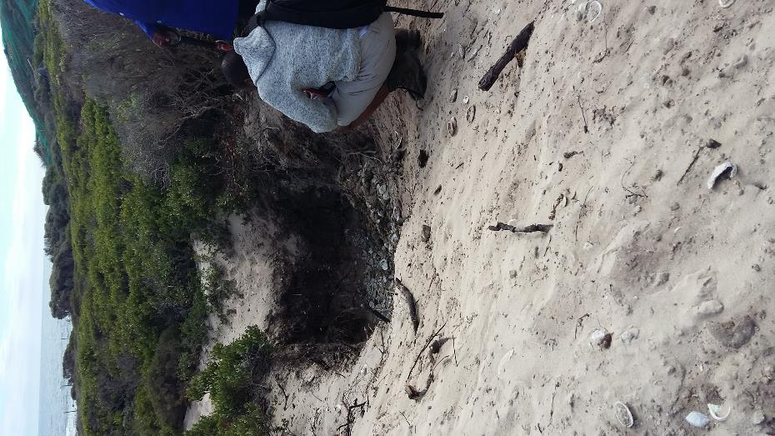
Site 005: This is a hole recently excavated into the soft soils near Turbine 1
Here we found one of the staff dumping some abalone shells from the abalone farm. She explained that these were natural deaths in the tanks, and the shells were buried to prevent a smell.

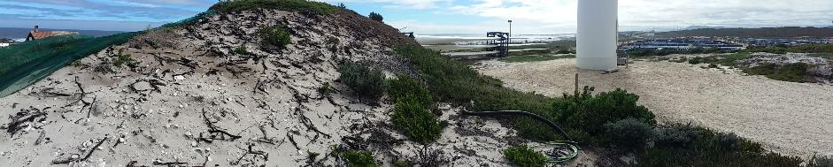
Dump of soil to the left, with marine shell visible on the top.
Sites 006/007 and 008: These are marine shell of archaeological origin which relate to a midden which has been destroyed by the excavations of the topsoil to create a flat platform for Turbine 1. Remnant shell from a midden is found along the sides of a large dump of soil. There are also archaeological shell on top of the dump, which have probably been deposited during construction.

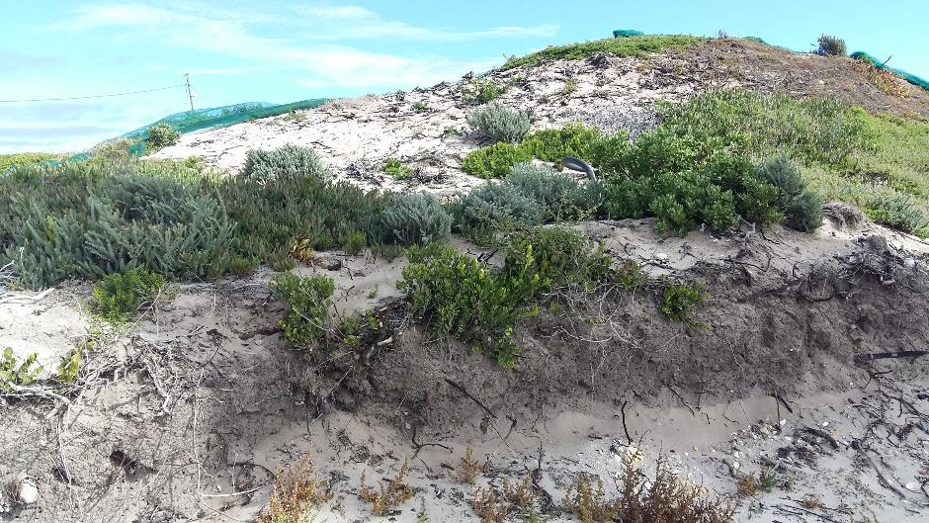
In situ soil deposits under the dump (visible in this cutting). Dump material from the excavations are on top.

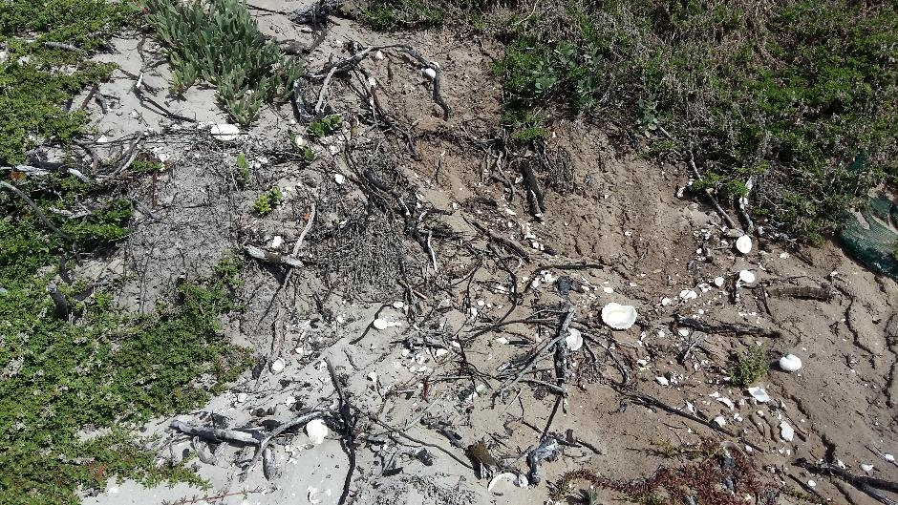
Scatters of marine shell visible in the collapsing profile of the hill. The shell include (S. argenvillei, C. granatina, Burnapena spp., Turbo sarmaticus and Haliotis spp.)

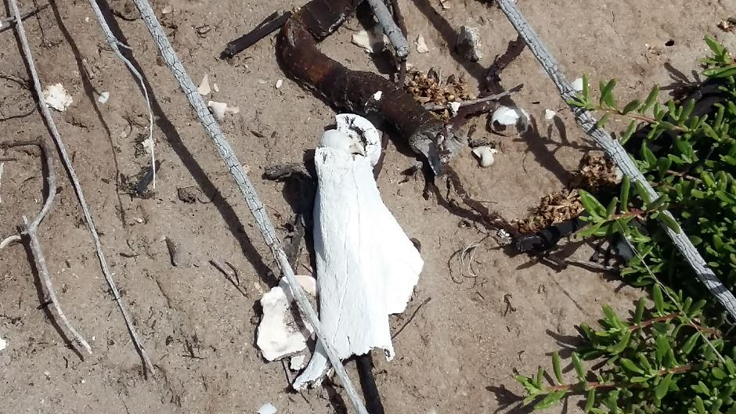
Fragments of bone and quartzite flakes are visible on the slopes

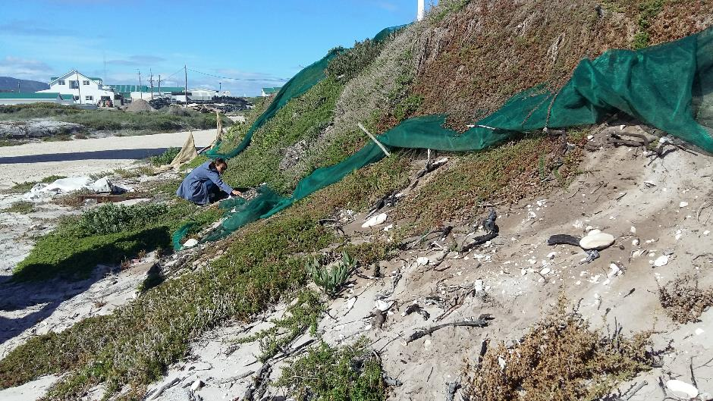

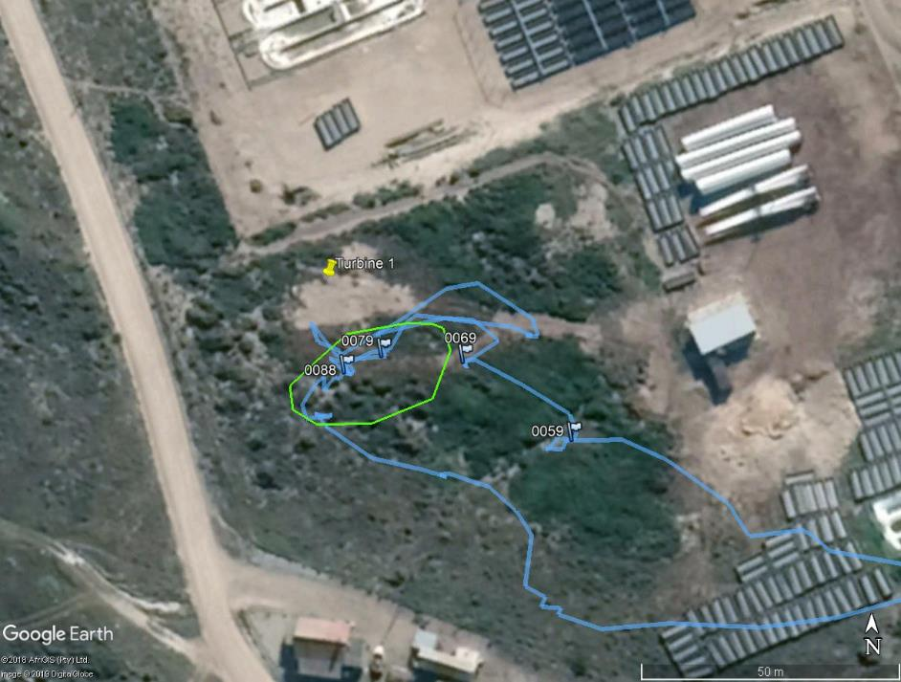
The area surveyed

Discussion:
It is difficult to determine if there is any in situ remains of the shell midden located under heap of soil dumped next to Turbine 1. There are, however, scatters of shell between the turbine and the gravel road to the south-west. This entire area has been significantly impacted by the development and it is unlikely that there are well-preserved middens left within the fenced abalone farm.
The shell midden next to Turbine 1 has been almost completely destroyed by the excavation of soils to create a flat platform for the turbine. It is possible that remnants may be located under the dump heap of soil, but this cannot be confirmed. The midden is probably of Grade IIIC significance. If proper procedure had been followed during construction of the turbine, and monitoring implemented, a sample of the midden could have been excavated for research purposes.

Visual Impact
Considered to be very low.

Recommendations by Site Inspection Team:

- Further archaeological investigations are not required.
- It is recommended that netting be placed over the heap of sand, and so that plant growth is encouraged, and the remainder of the site is preserved. No construction should take place here.

APM Committee discussed the following:
- HIA by ACRM
- Wind turbines were erected on an archaeological site with high negative impact and has had considerable disturbance of archaeological material.
- The site inspection report confirmed that the visual impact from the land is low.
- The site inspection team considered and suggested a suitable wind turbine location for T3.
- There is potential for archaeological sampling.

APM Committee Comment:
• The site inspection report and findings is noted and endorsed.
• The site is Graded IIIC.

